DRONE PILOT E-LEARNING PLATFORM

Name Of Application
Drone Pilot E‑Learning Platform (ZETDC E‑Learning)

1.0 Abstract
The Drone Pilot E‑Learning Platform is a web‑based training and assessment system for aeronautical/drone pilot education. It streamlines delivery of learning modules, compliance management, and proctored assessments while tracking learner progress and instructor activity. Built on Laravel 10 with Blade + Livewire, it provides an admin console for course orchestration, a student portal for content and exams, and an instructor portal for facilitation and compliance. The platform integrates API documentation for external integrations, and includes reporting, aircraft and school records, ratings, and regulatory document tracking to support a compliant training lifecycle.

2.0 Introduction

2.1 Purpose
The system digitizes drone-pilot training workflows to improve scalability, reduce administrative workload, and enforce aviation-training regulatory compliance.

2.2 Target Audience
- Training administrators
- Drone pilot instructors (tutors)
- Students (trainees)
- Compliance and auditing personnel

2.3 Technology Stack
- Backend: Laravel 10, PHP 8.1
- Authentication: Breeze, Sanctum
- Frontend: Blade templates, Tailwind CSS, Livewire v2
- API Documentation: L5-Swagger
- Utilities: DOMPDF (PDF generation), Simple QRCode, Livewire Alert

2.4 Key System Capabilities
- Role-based user management (Admin, Tutor, Student)
- Course and module creation with instructor assignment
- Exam engine with question bank, automated scoring, and attempts tracking
- Compliance management for instructors, aircraft, and schools
- Aircraft and aviation-school records repository
- Student portal for module access and assessment
- Integration-ready APIs secured with Sanctum
- Analytics and detailed reporting

3.0 Problem Definition
Traditional drone pilot training faces several challenges:

3.1 Administrative Overhead
Manual tracking of qualifications, scheduling, and paperwork is time-consuming and prone to error.

3.2 Compliance & Auditability
Regulatory bodies require accurate tracking of instructor credentials, aircraft documents, and training activity.

3.3 Assessment Integrity
Managing question banks, exam scheduling, grading consistency, and feedback without a centralized system is difficult.

3.4 Fragmented Data Sources
Student progress, exam attempts, and compliance documents exist across spreadsheets and files, making reporting unreliable.

3.5 Limited Integrations
Partner systems, mobile applications, and LMS/LRS platforms require standardized API access.

4.0 System Overview
4.1 Architecture
The platform uses an MVC architecture through Laravel with Livewire for rich interactivity. Core modules include:
- Users & Roles
- Modules & Content
- Exams & Assessments
- Compliance (Instructor, Aircraft, School)
- Ratings & Certifications
- Reporting
- API Integration
4.2 Key Modules
4.2.1 User & Role Management
- Users categorized as Admin, Tutor, or Student
- Admin middleware for privileged access
- Centralized authentication via Breeze + Sanctum
4.2.2 Module & Content Management
- Create and manage drone-pilot learning modules
- Assign instructors to modules
- Seeded UAS-specific content (e.g., Navigation, Safety, UAS Fundamentals)
- Livewire-powered module management dashboard
4.2.3 Exams, Tests & Question Bank
- Question banks linked to modules
- Multiple-choice, single-answer question structures
- Exam configuration: thresholds, scheduling, status
- Automated grading and results storage
- Tutor involvement in question curation
4.2.4 Compliance Management
Tracks required documentation for:
- Instructors
- Aircraft
- Training schools
Includes expiry monitoring, uploads, and record status tracking.
4.2.5 Aircraft & School Registry
- Detailed aircraft information
- Document compliance for aircraft and schools
- Livewire components for record management
4.2.6 Student Portal
- Access to assigned modules
- Ability to take module tests/exams
- View exam history and results
- Download documents (PDFs, certificates)
4.2.7 Reporting & Analytics
- Aggregated reporting for students, modules, exams, and instructors
- Compliance summary dashboards
4.2.8 API & External Integrations
- REST APIs with JWT/Bearer authentication
- Fully documented with Swagger UI
- Ready for mobile or partner integration

5.0 Objectives
The platform aims to:
- Create a unified digital environment for drone-pilot training
- Ensure compliance with aviation regulations
- Support transparent and fair examination workflows
- Provide role-based access to learning and management tools
- Enable secure integration with external systems

6.0 Use Case Diagram
Admin
- Manage modules
- Assign instructors
- Create questions and exams
- Track compliance
- Manage aircraft and school records
- Monitor student results
- Generate reports
Tutor
- View assigned modules
- Manage and upload course content
- Propose or modify questions
- Monitor student performance
- Maintain compliance documents
Student
- Register and login
- Access modules
- Attempt tests/exams
- View results and download PDFs
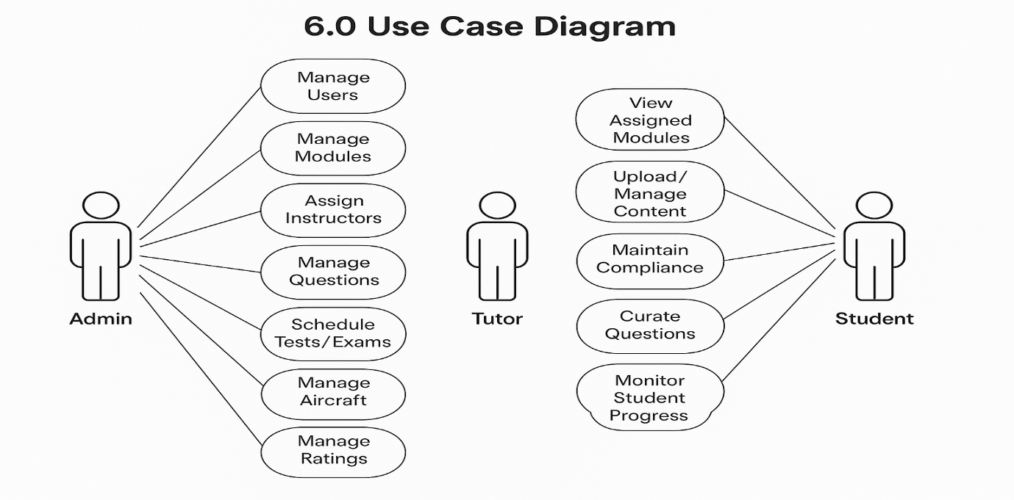

7.0 Screenshots

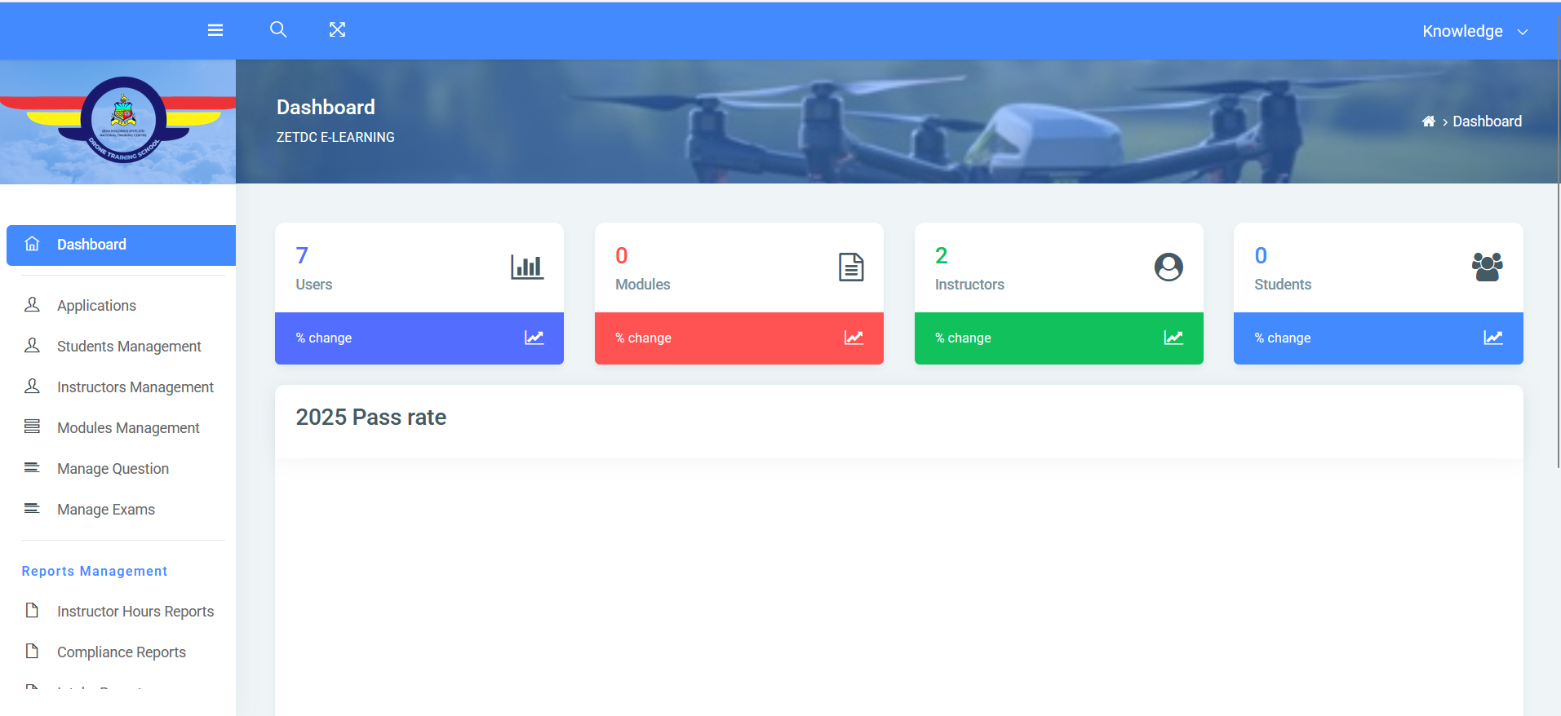
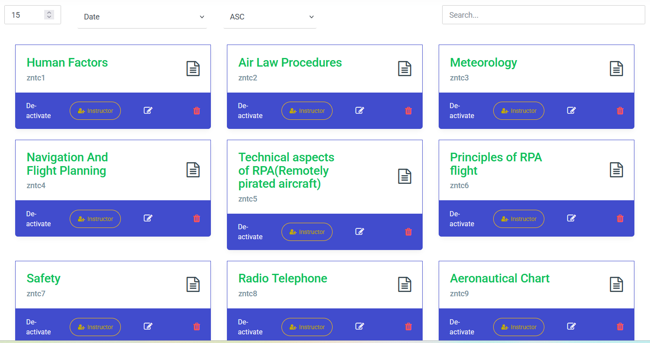

8.0 Conclusion
The Drone Pilot E-Learning Platform provides an end-to-end solution for drone-pilot training management, addressing instructional delivery, assessments, compliance tracking, and data reporting within one centralized system.
Leveraging Laravel, Livewire, and modern authentication tools ensures scalability, maintainability, and secure integration with external systems.
Future enhancements may include:
- Advanced analytics & performance dashboards
- Certificate generation with QR validation
- Adaptive learning paths
- Integration with broader LMS/LRS ecosystems

